*TalkBox* *Simulator* User Manual

**Requirements: *Java* must be installed. Click** [here](https://www.java.com/en/download/) **to install.**

Before using the simulator, the user must use the *Talkbox Configurator* application to configure the appearance and functionality of the buttons. After creating their custom configuration and setting it in a directory, the user can now use the simulator.

There are two buttons at the main menu. The **Open Talkbox Configuration** button allows the user to open their existing configuration. It will open to a window that lists all the directories. The user selects the directory that they saved the configuration in. The **Simulate Configuration** button will light up and will be ready to use. Note that invalid or corrupted configurations will *fail* to load.

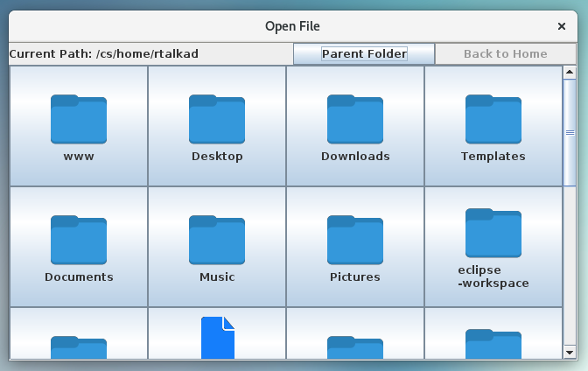*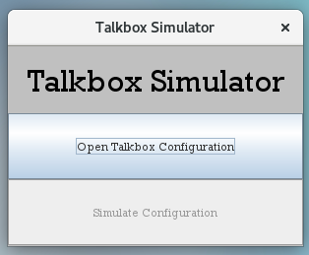The simulator menu has two buttons.*

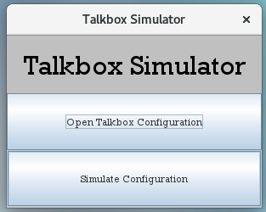

The **Simulate Configuration** button launches the main interface of interactive buttons with their saved configurations. If the user wishes to change any one of these configurations, they should close the simulator and go back to the configurator.

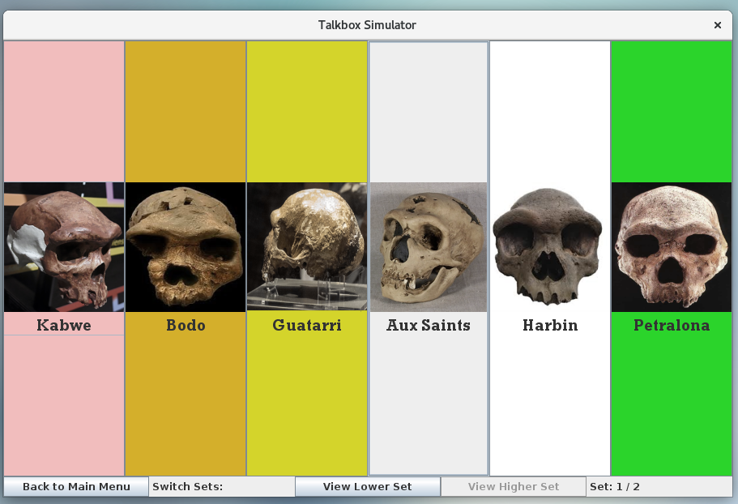*The previous configuration will be loaded.*